LAB-2

Question I : Print Largest and Smallest Values Out of Two

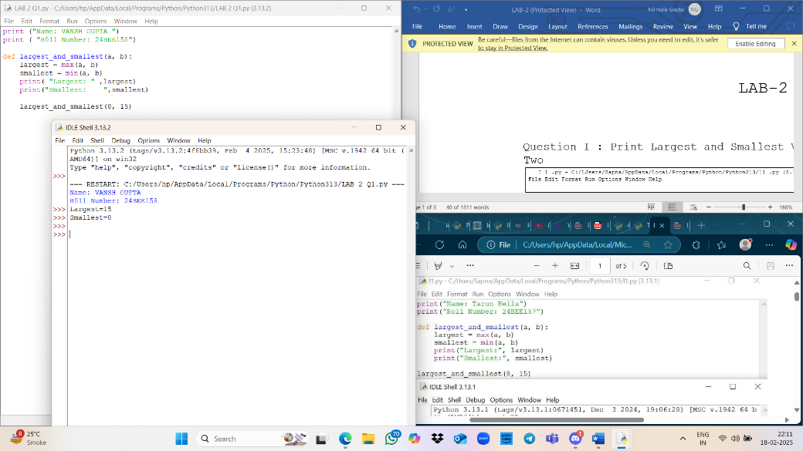

|  |
| --- |
|  |

Question 2: Print Largest and Smallest Values Out of Three

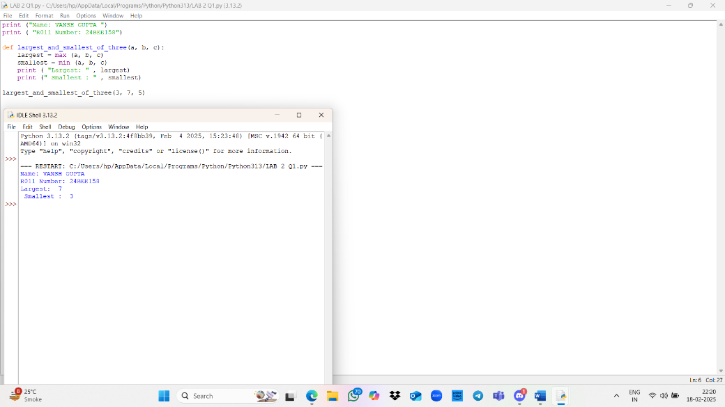

Question 3: Check Whether a Given Number is Odd or Even

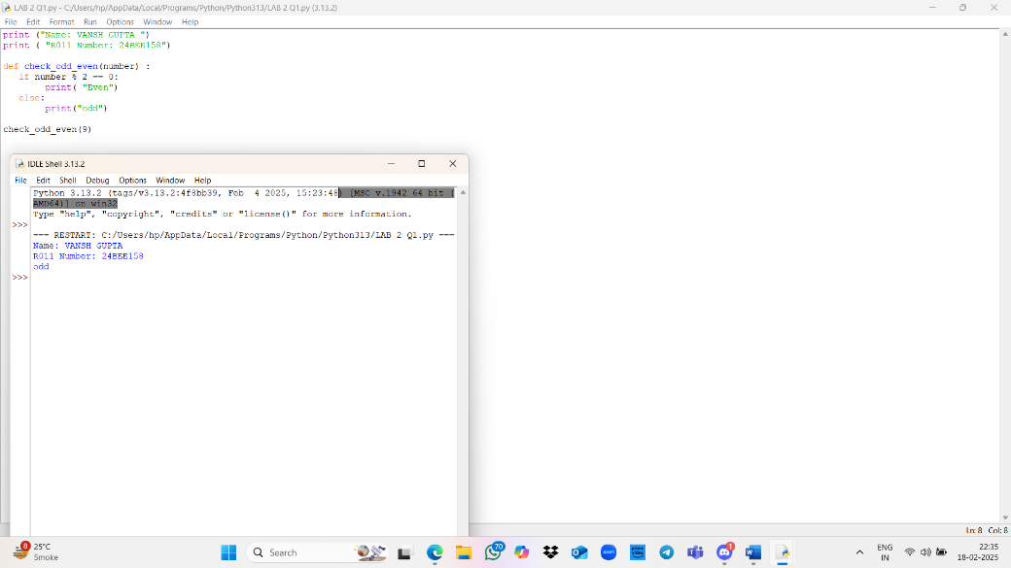 4: a Given Number is Divisible by 10 or Not

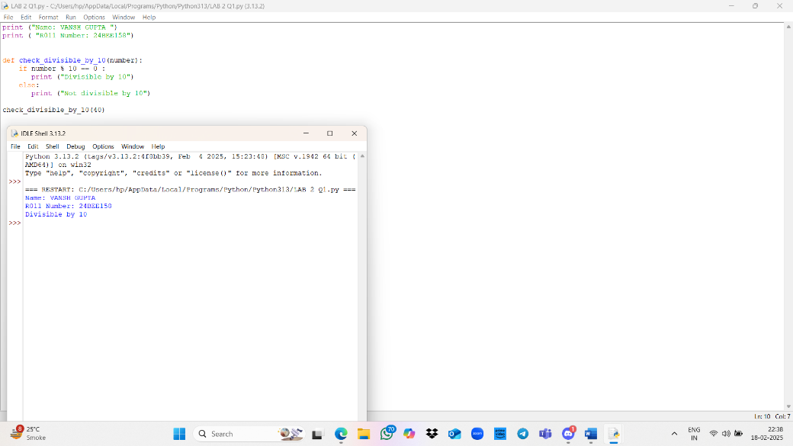

Question 5: Accept Age of a Person and Print Minor or Major

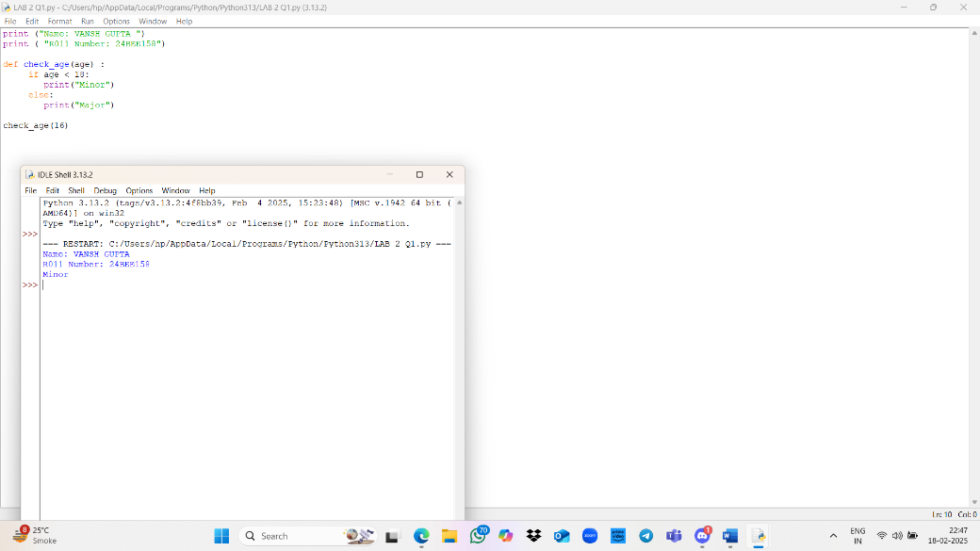

Question 6: Accept a Number from the User and Print the Number of Digits in It

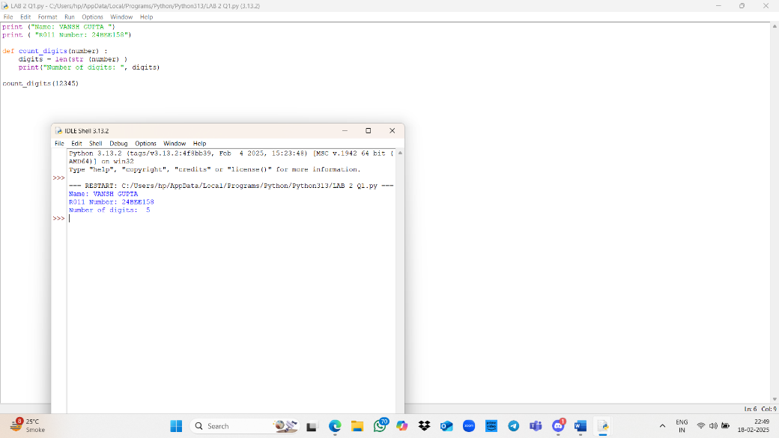

7: a Year is a Leap Year or Not

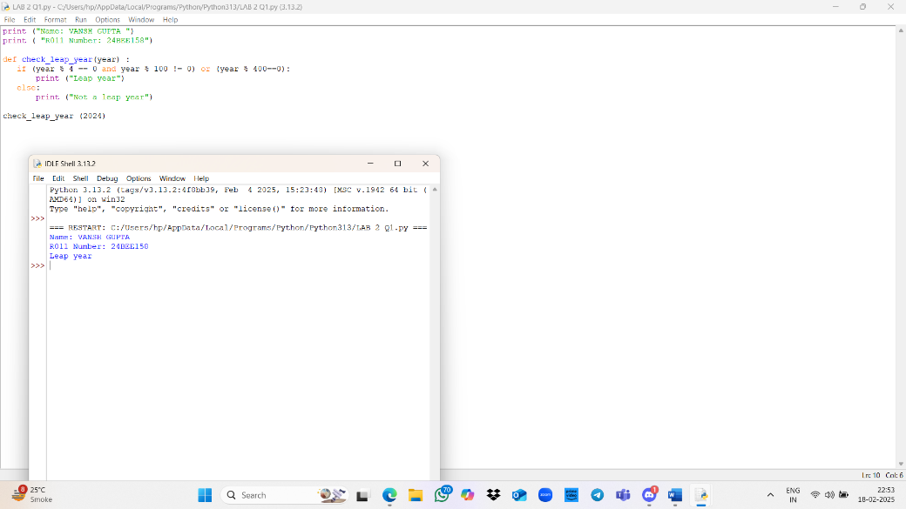

Question 8: Check Whether a Triangle is Valid or Not Based on Angles

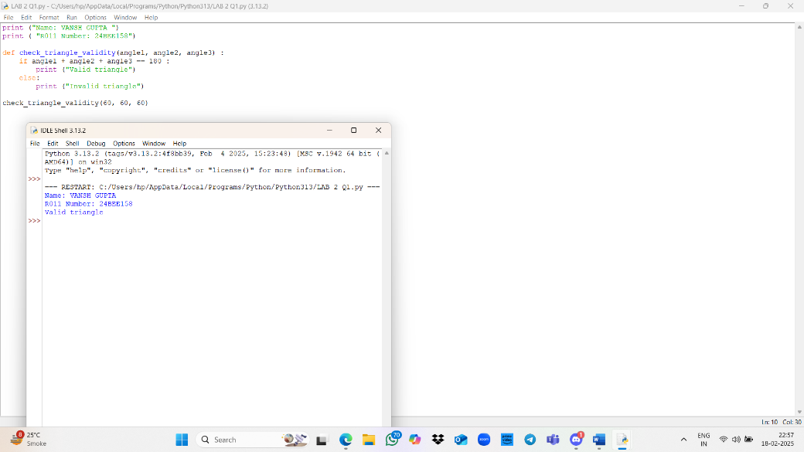

>>>

Question 9: Print Absolute Value of a Given Number

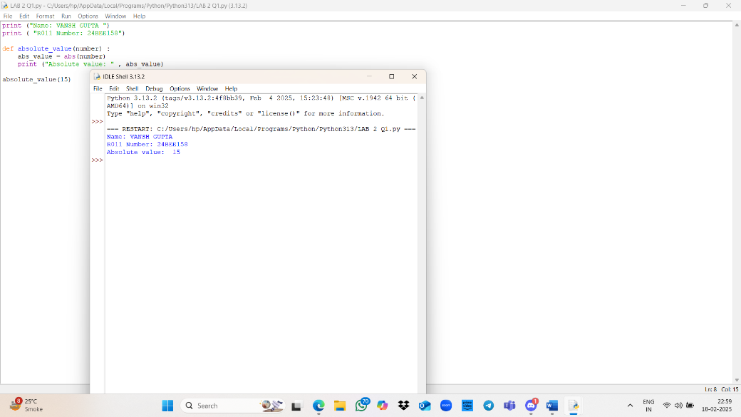

10: the Area of a Rectangle is Greater than Its Perimeter

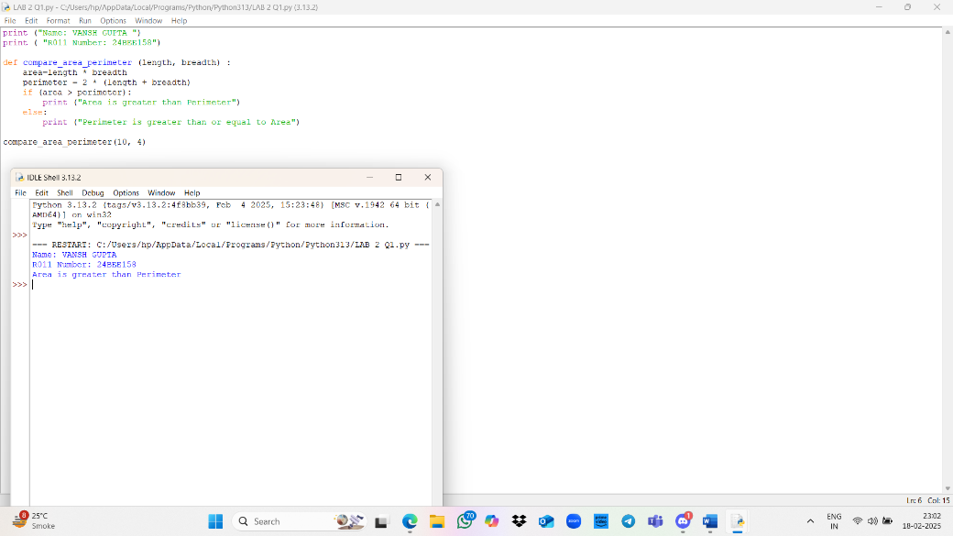

Question 1 1: Check If Three Points Are Collinear

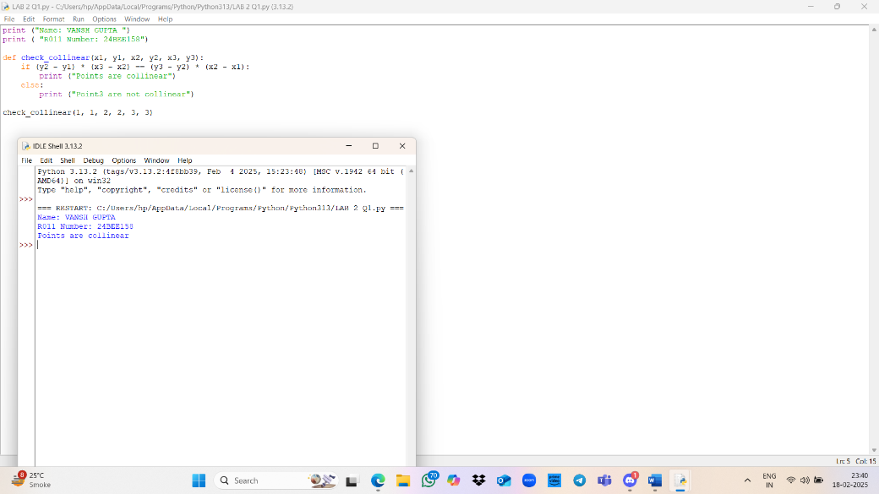

Question 12: Check Whether a Point Lies Inside, On, or Outside a Circle

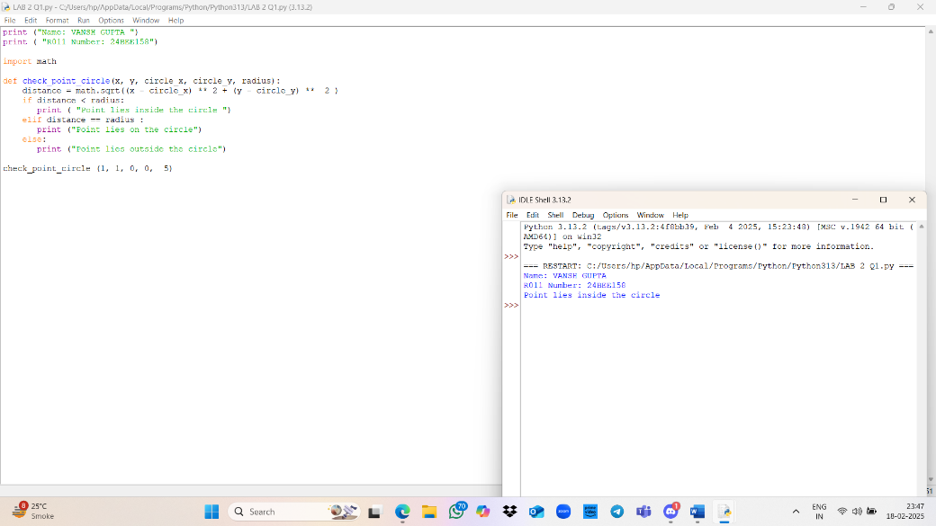

Question 13: Convert Number 0 to 19 to Its Equivalent Words

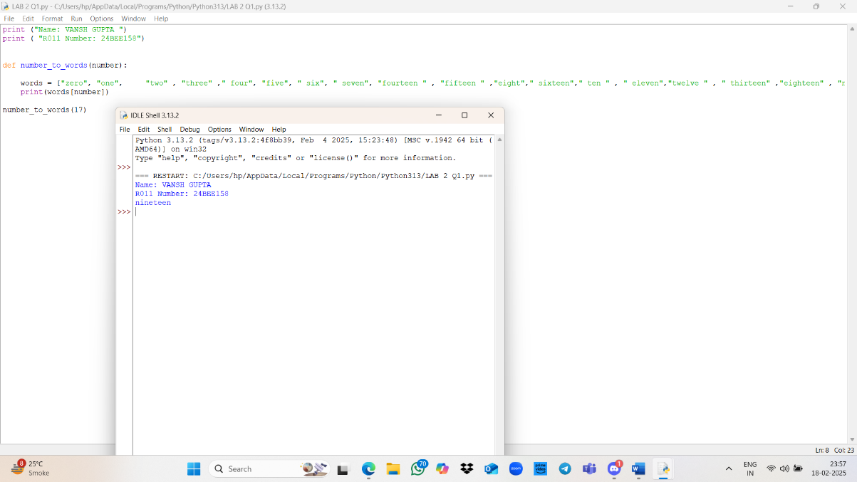

Question 14: Accept Marks of Three Subjects and Print Total,

